**Assignment 12**

**Problem Statement:** Deploy and run the project in AWS without using port.

Steps:

1. At first go to EC2 dashboard and then remove all security group except default, and then click on Create security group

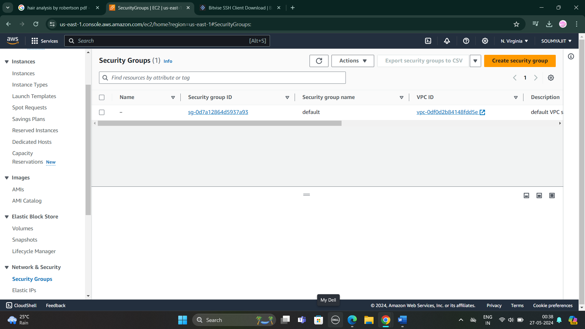

1. Now give its proper name and description (Same as Name).

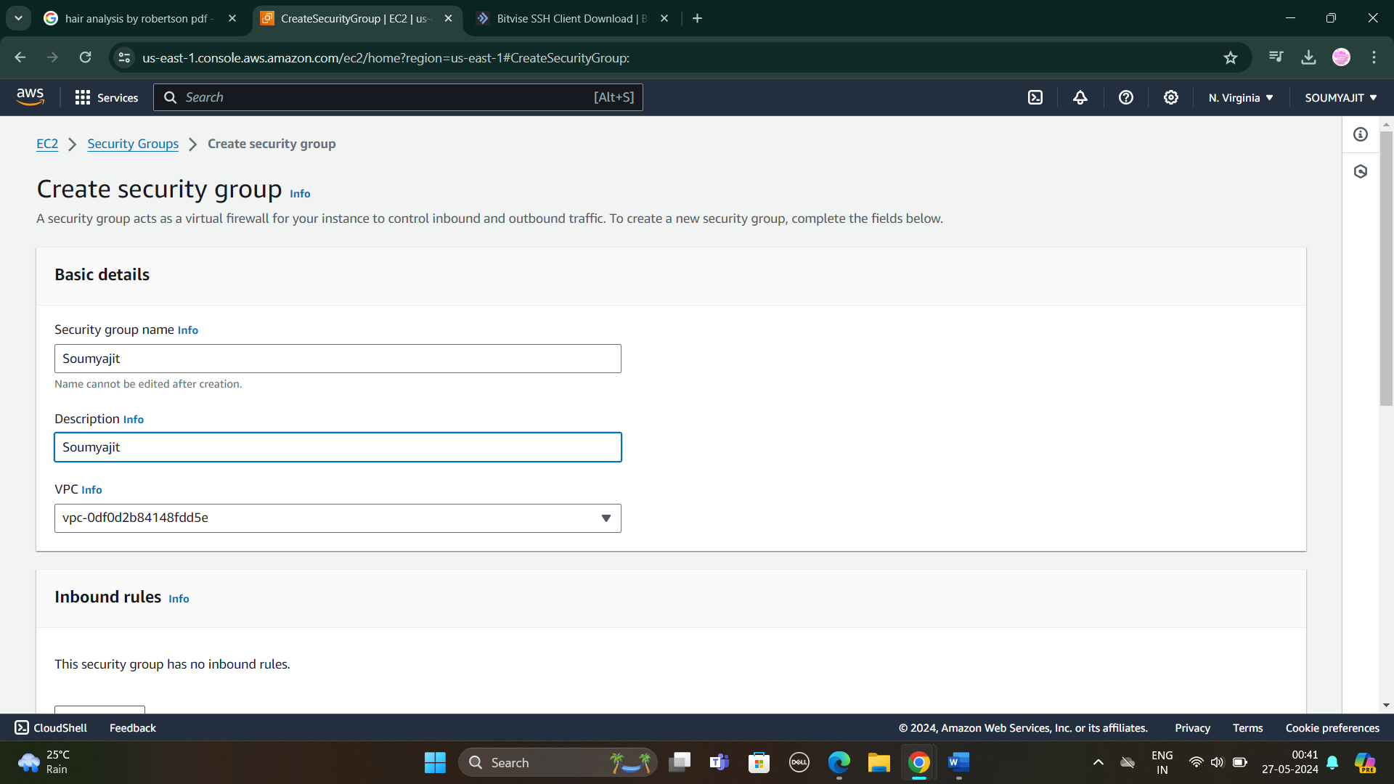

1. Now in inbound click on “Add rule” and in this way add 4 security rules (Custom TCP, SSH, HTTP, HTTPs). Then click on “Create Security Group”

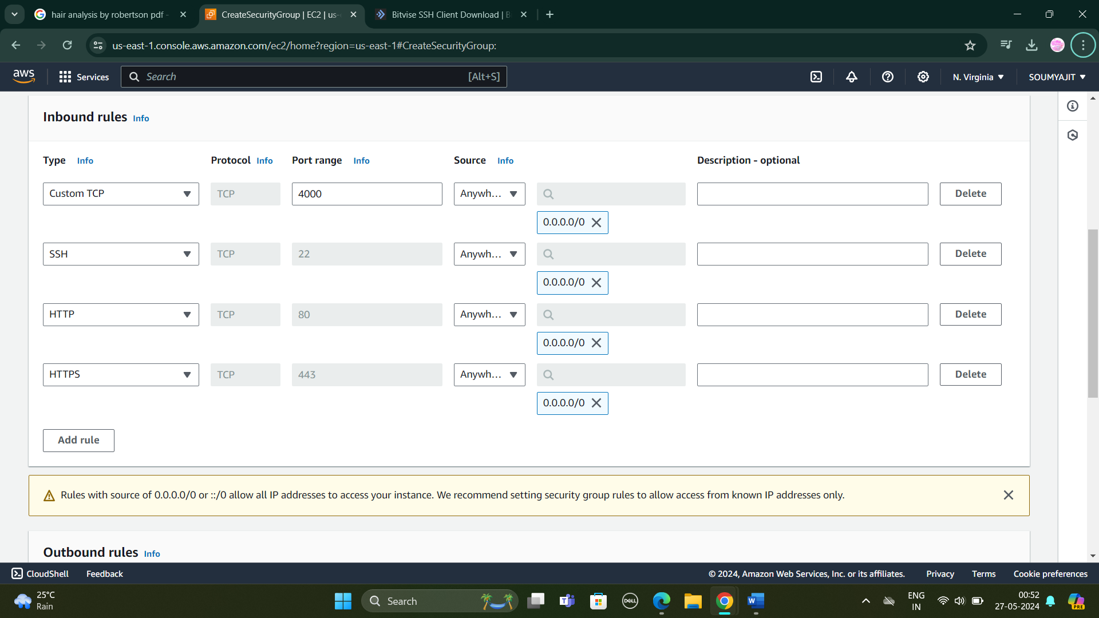

1. Security group is created successfully.

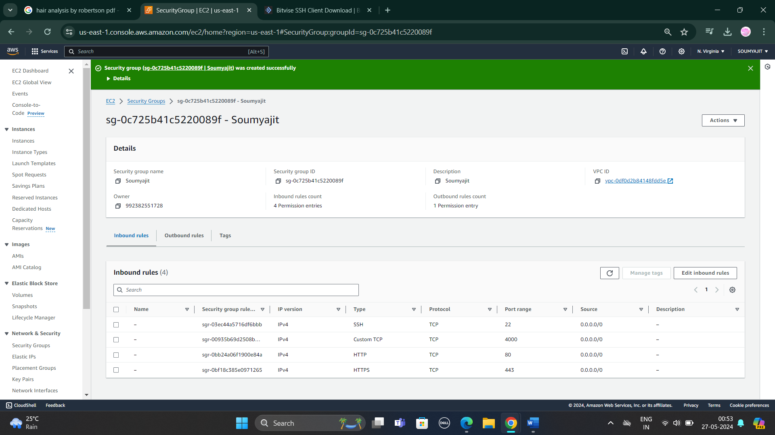

1. Go to EC2 dashboard and click on Launch Instance

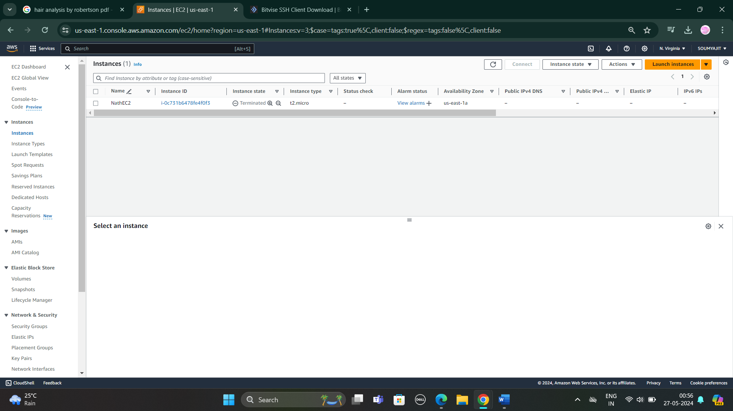

1. After it give a unique name and then click on Ubuntu.

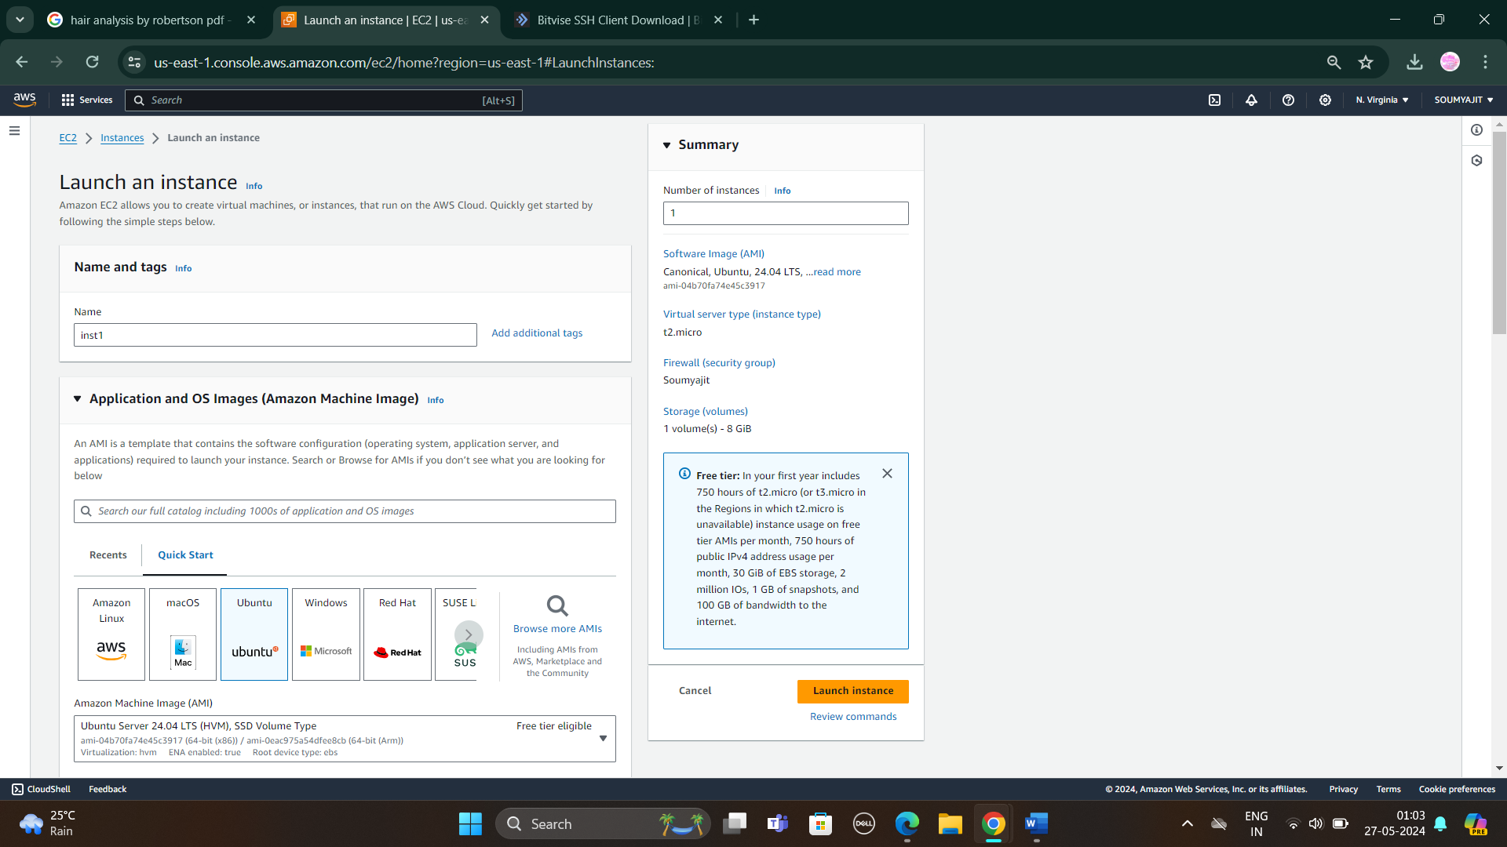

1. Now select key pair and in network settings also click on “Select existing security group” then select the security group which was created and click on Launch Instance.

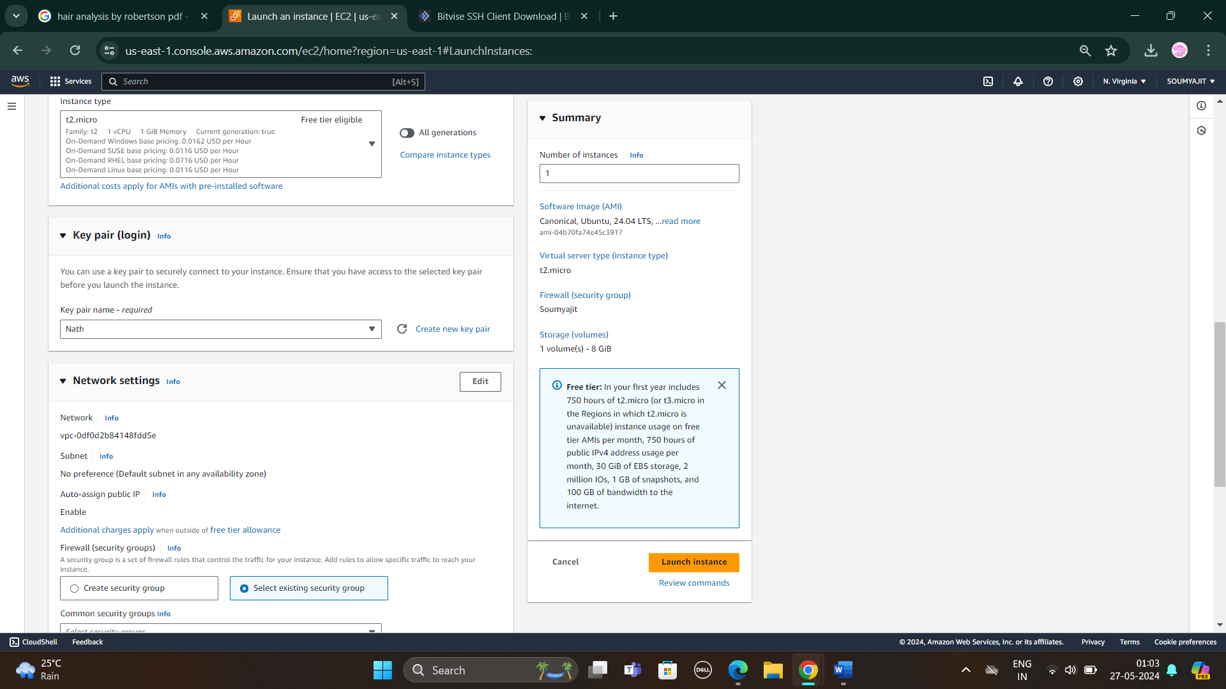

1. Instance created. Click on instance and copy the IPV4 address.

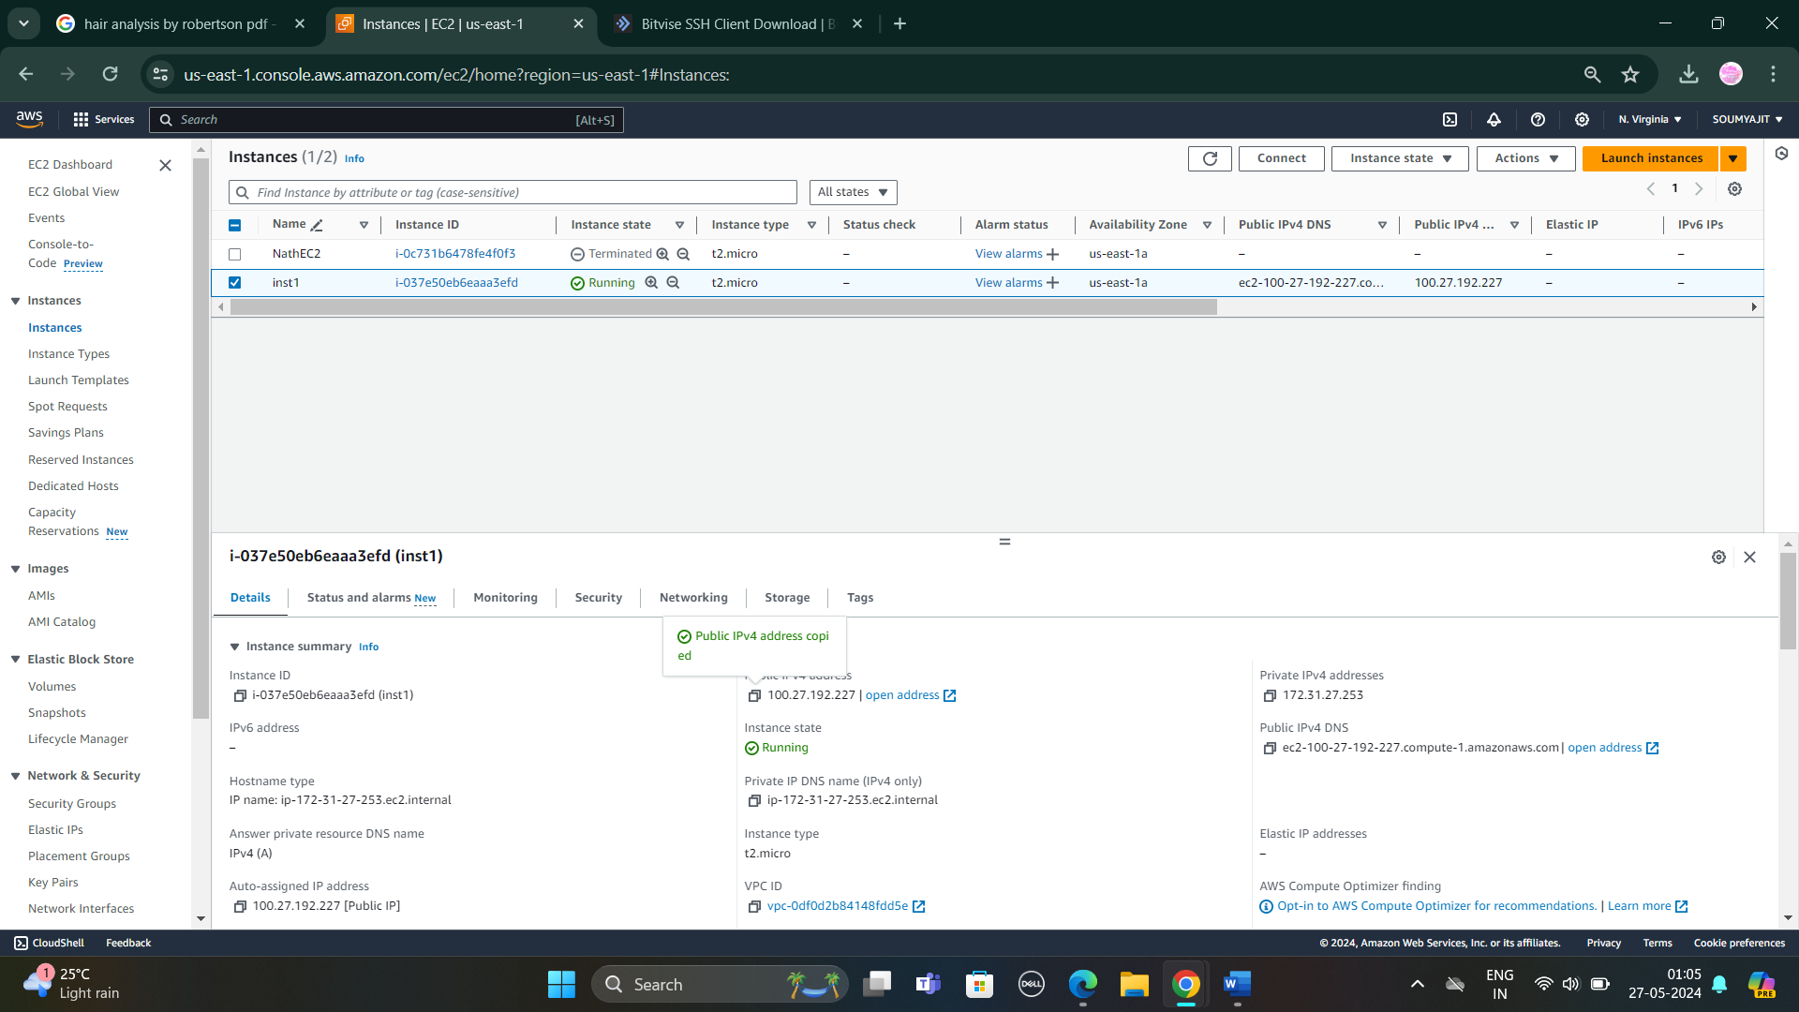

1. Paste the IPv4 address in host of BitVise SSH client and import key pair in Client key pair manager. After that click on Log In

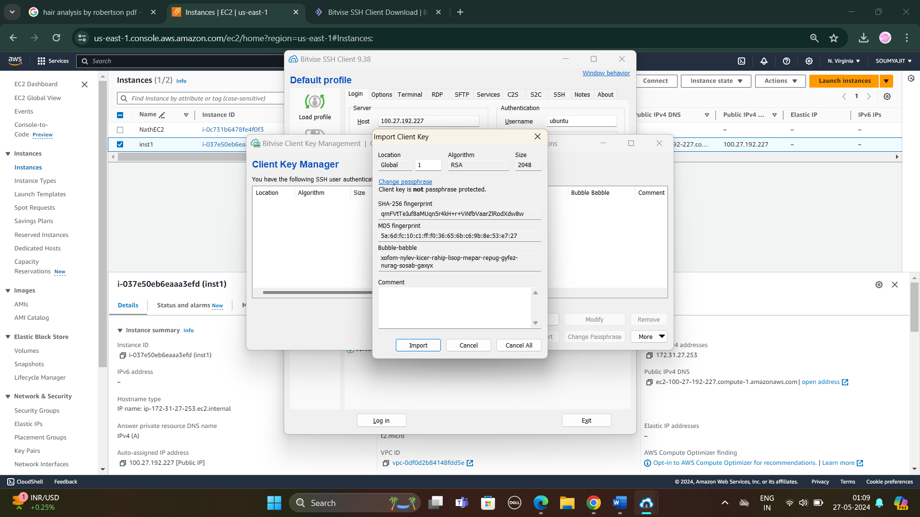

Click accept and save then log in

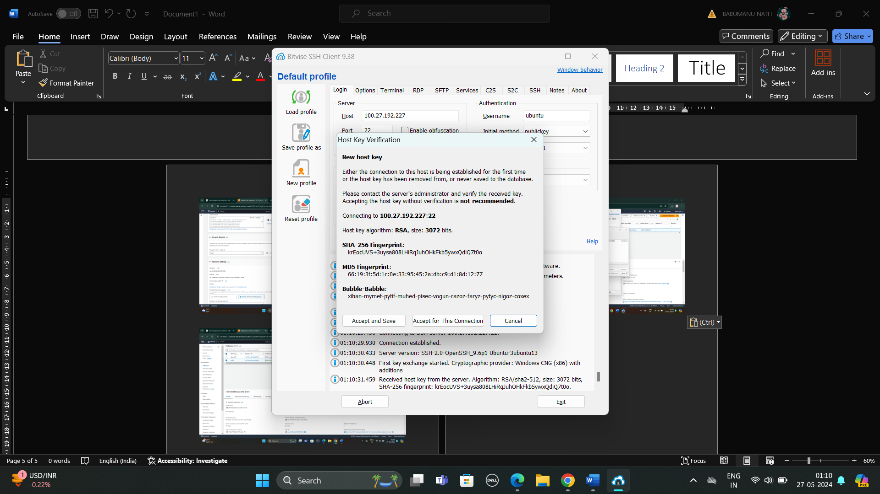 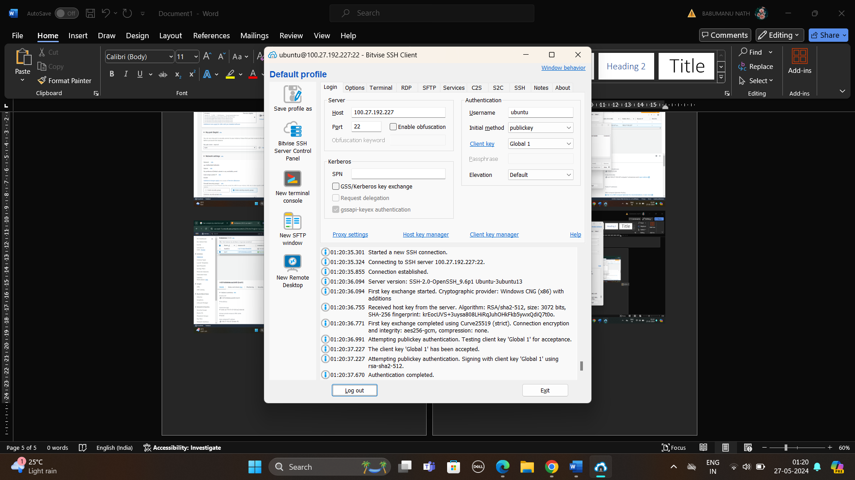

1. Now open terminal in BitVise SSH and then write all commands:

Pwd

sudo apt-get update

sudo apt-get upgrade

sudo apt-get install nginx

curl -SL https://deb.nodesource.com/setup_16.x|sudo -E bash

sudo apt-get install nginx

git clone <https://github.com/sudip7407/Repo1.git>

cd Repo1

npm install

node index.js

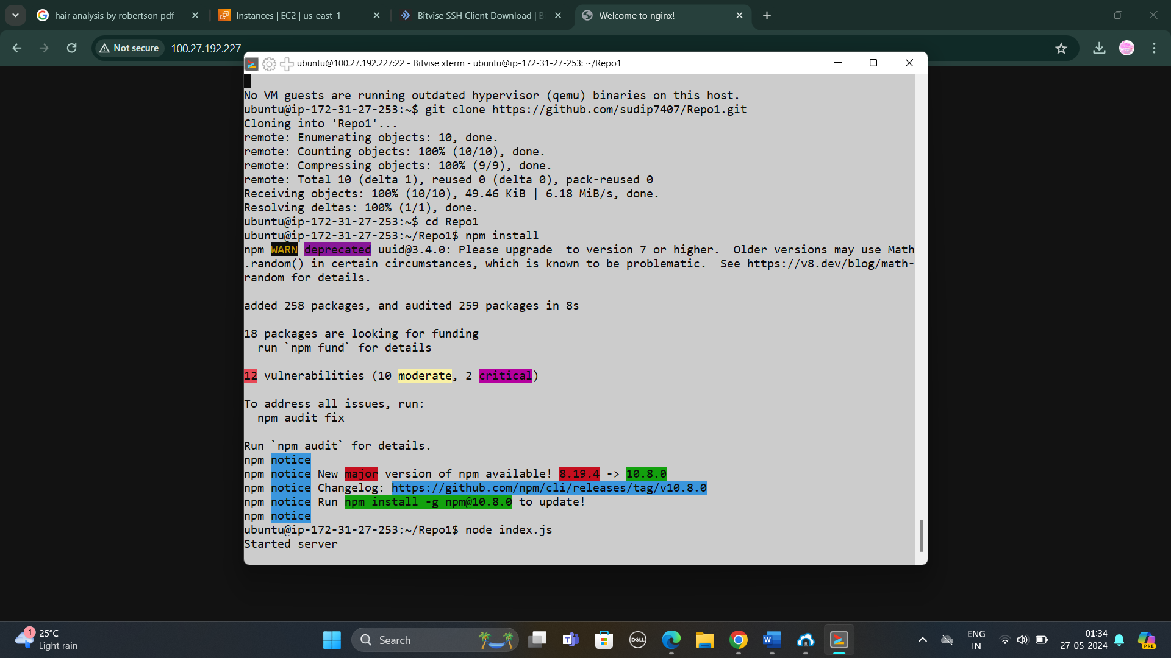

Now server has started. If we paste it in url section then we can see nginx has started. To stop server click (ctrl+c)

1. Then paste the IPV4v address into the browser then this message is shown

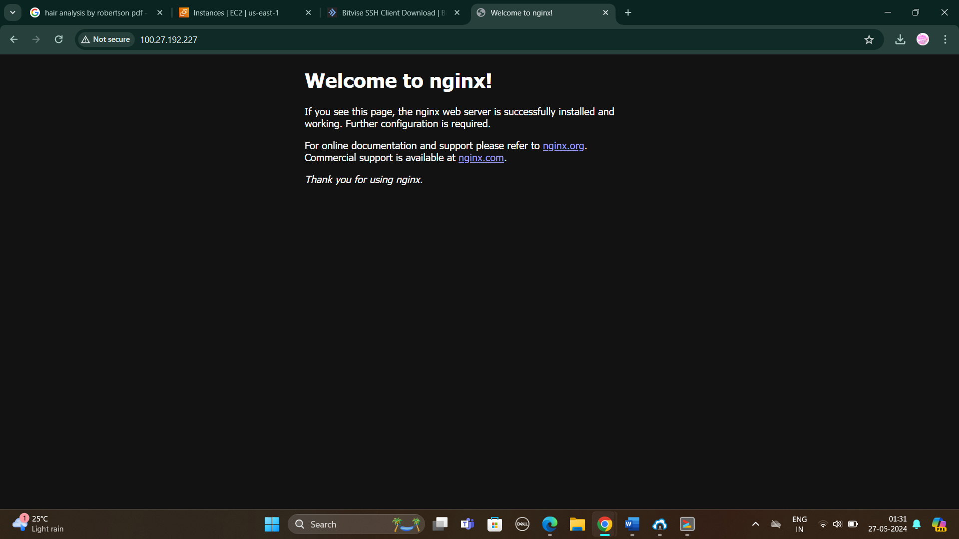

1. Now write these all commands:

cd /

pwd

cd etc/nginx/sites-available/

sudo nano default

1. A new window will be opened. There at first go to location area and comment all codes and the write

location/{

proxy_pass http://localhost:4000;

proxy_http_version 1.1;

proxy_set_header Upgrade $http_upgrade;

proxy_set_header Connection ‘upgrade’;

proxy_set_header Host $host;

proxy_cache_bypass $http_upgrade;

}

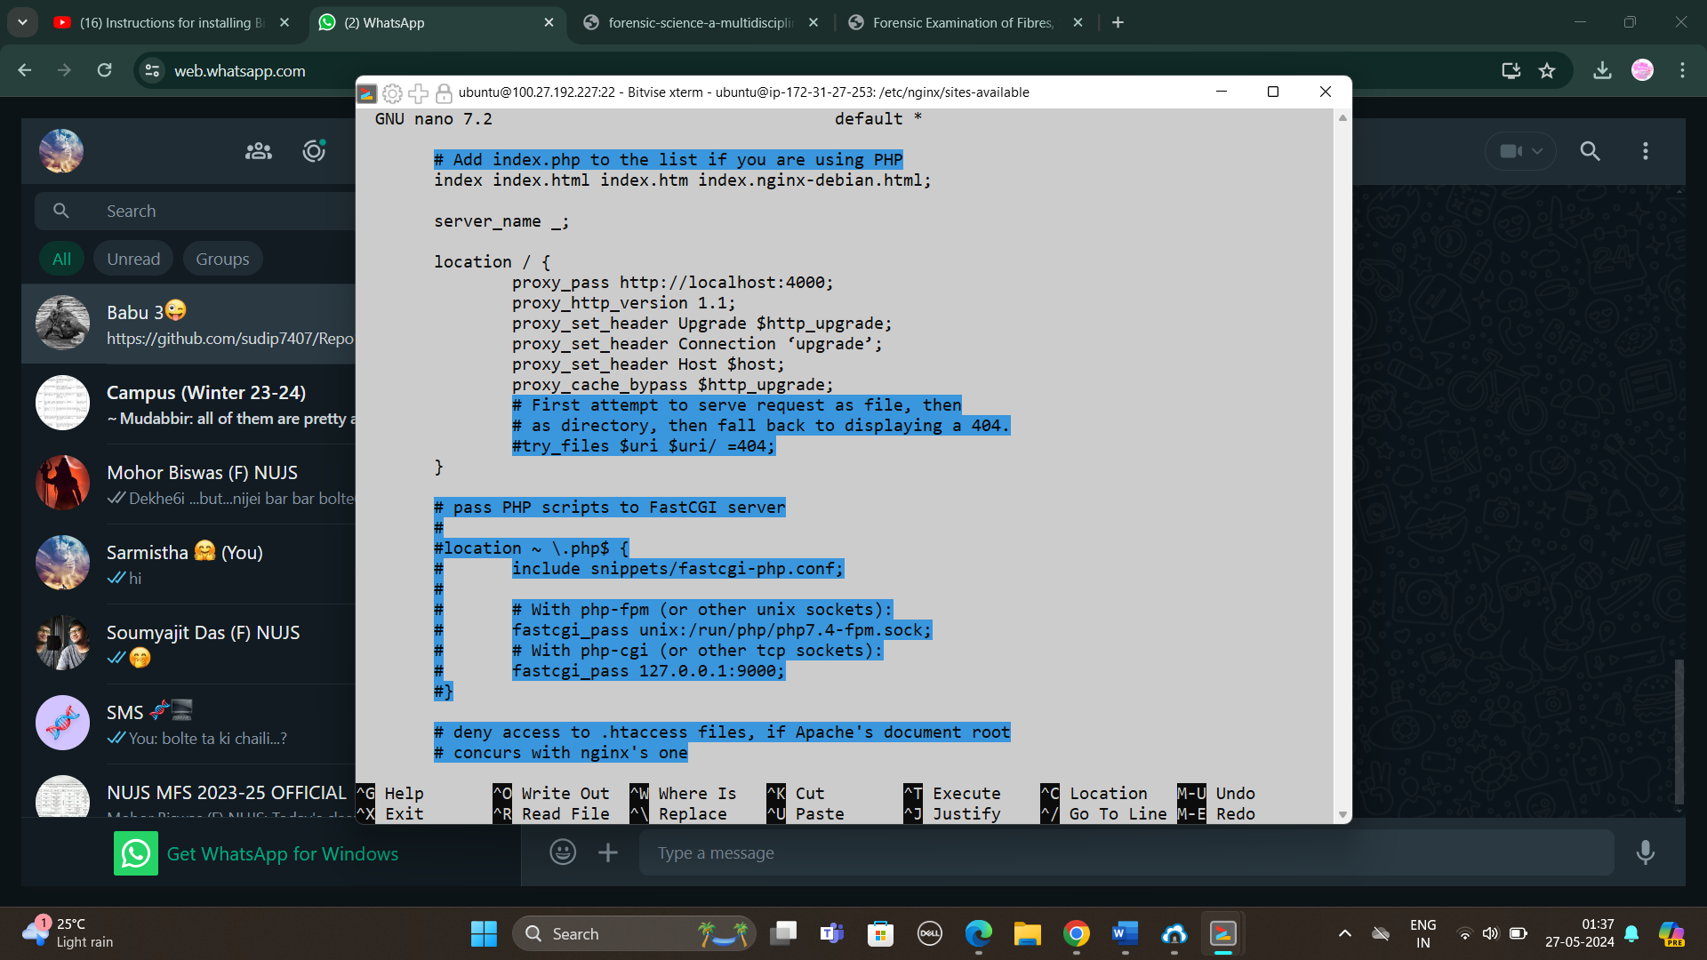

->After write the code click ctrl+x, then y then click enter

1. Now open new terminal and write the commands

cd Repo1

sudo systemctl restart nginx.

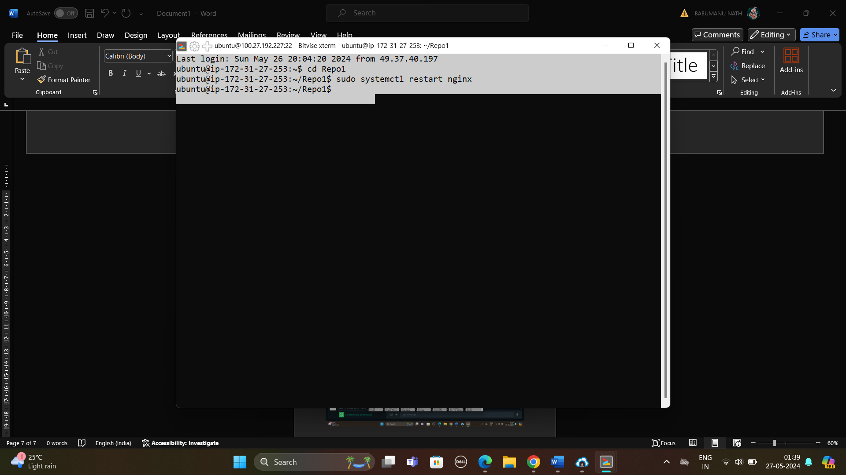

1. Now copy that public IPv4 address again and paste it in url and there we can see that without giving port(:4000) with url we have hosted the website

